Relational Database Project Proposal

Introduction

Our proposal for an application based on a relational database consists in the development of a software solution designed to meet the data management requirements of a fictional tech company named *Innovative Solutions*.  
The company’s business consists in the retailing of electronical IoT-oriented products assembled in-house by teams of employees from their constituting components, which in turn are bought from various suppliers.

Requirements

The company requires a software solution which on one hand allows the management to oversee and control all the information concerning the company’s production process, and on the other enables customers to directly purchase the products on offer and keep track of their orders.

Working Hypotheses

The design of the software solution that will be proposed to the company is based upon the following working hypotheses:

* *Customers* may purchase any *Products* up to their available quantity
* Each *Employee* in the company may belong to up to one *Team*
* *Teams* are assigned to the assembly of the *Products* offered by the company, where each *Product* is assembled by a single team
* *Products* are composed of one or more *Components*
* *Components* are purchased from a list of *Suppliers*, where different suppliers may offer the same component at different prices

Software Architecture

The software will consist in a front-end module written in Java providing a graphical interface through which users following an authentication process can connect to an underlying MySQL database, where the actions they can perform on the latter depend on their level of privilege.

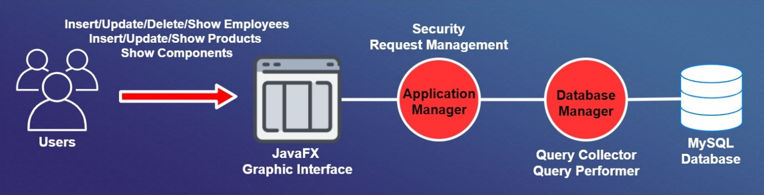

Actors

The software is meant to be used by three different actors:

* The company’s system administrator, who is permitted to perform a number of actions a high level of privilege.
* The team leaders, who are allowed to manage the members and the products assigned to their teams
* The customers, who may view and purchase the products on offer, as well as review their past orders.

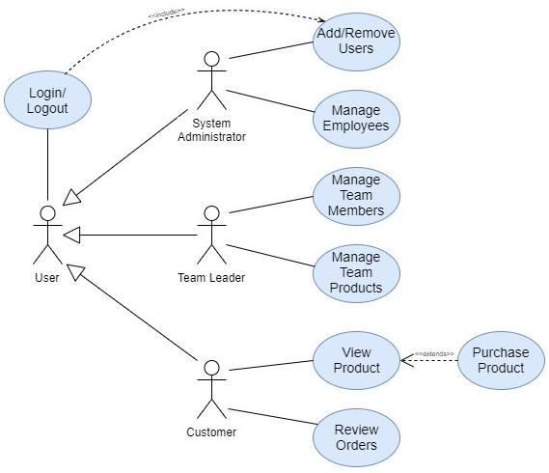

Application Dataflow

The projected dataflow of the application is outlined below:

